EXCEL PLUS DOCUMENTATION

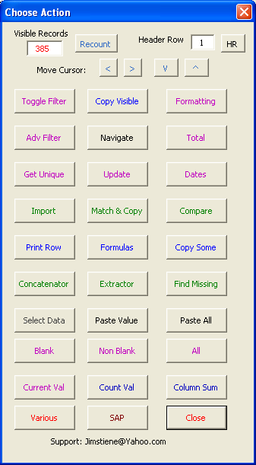
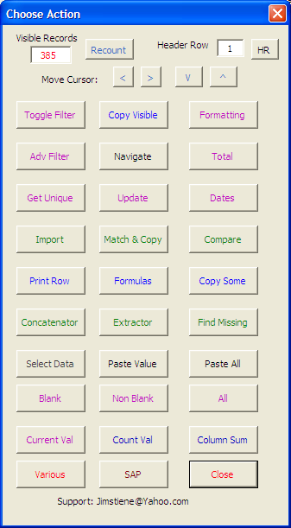
Filters column cursor is in to value of cell cursor is in.
Toggle filters on and off, based on header row
Sends row your cursor is in to printable sheet.
Filters column cursor is in to blank cells
Counts visible rows from header row to last row
Selects all data from header row to last row
Lists how many times the value of current cell appears in it’s column.
Pastes values from clipboard to cursors’ cell
Copies unhidden rows from header row to last row into new workbook
Pastes values, formats and column widths from clipboard to cursors’ cell
Filters column cursor is in to nonblank cells
Pulls row cursor is in to header row
Moves cursors up down left and right
Filters column cursor is in to all values
Gives total, count, min max average of column cursor is in
This is the Main form The HR button will pull the row your cursor is in into the Header Row textbox. Most of the functions in this tool depend on the header row. The Recount button counts how many rows are visible from the header row to the bottom row of data in column A. The arrow buttons at the top of the form move your cursor up, down, left and right. The Toggle Filter button is to turn filters off and on based on the header row.

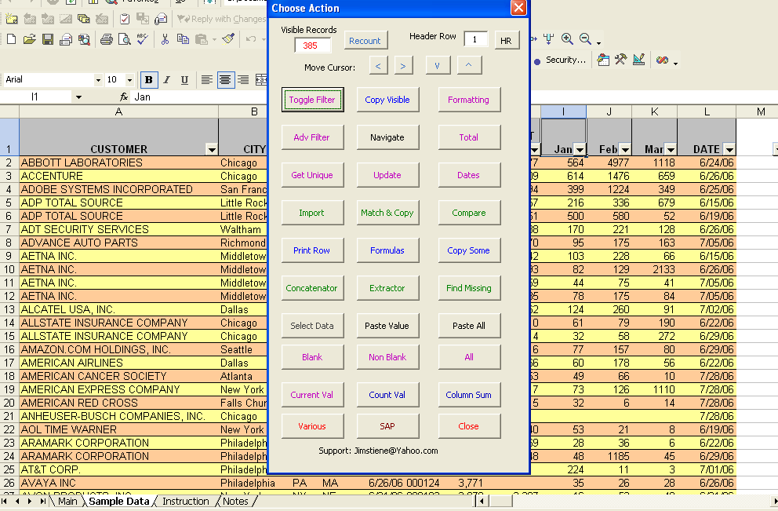
Hit the Toggle Filter button, choose Chicago as a City, and hit the Recount button. Notice how the row count changes. Now hit the Copy Visible Button.

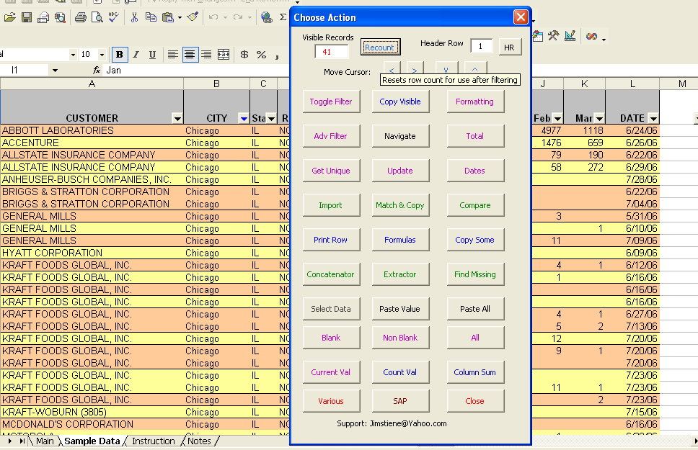

A new workbook is created with only Chicago copies. Notice cell A1 says “Limited to Chicago.” The Copy Visible buttonl reads what filters you had on before copying. You may notice in Cells D1 and E1 a record count shows how many rows of data there are. Close the new workbook and go back to Excel Plus’ Data Sample page.

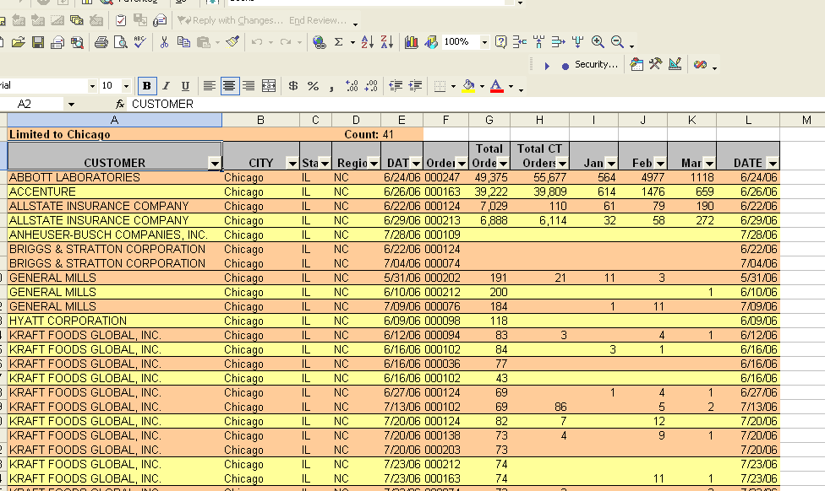

Hit CTL-E or Excel Plus from the top Menu of Excel to bring up the Main form again, if its not still open Put your cursor somewhere in column B of the Sample Data tab and hit the All button. This turns the Autofilter to All in that column so Chicago isn’t the only city showing. Now put your cursor somewhere in column J or K and hit the Blank and Non Blank buttons. Then hit the All button again. Notice how visible rows change.

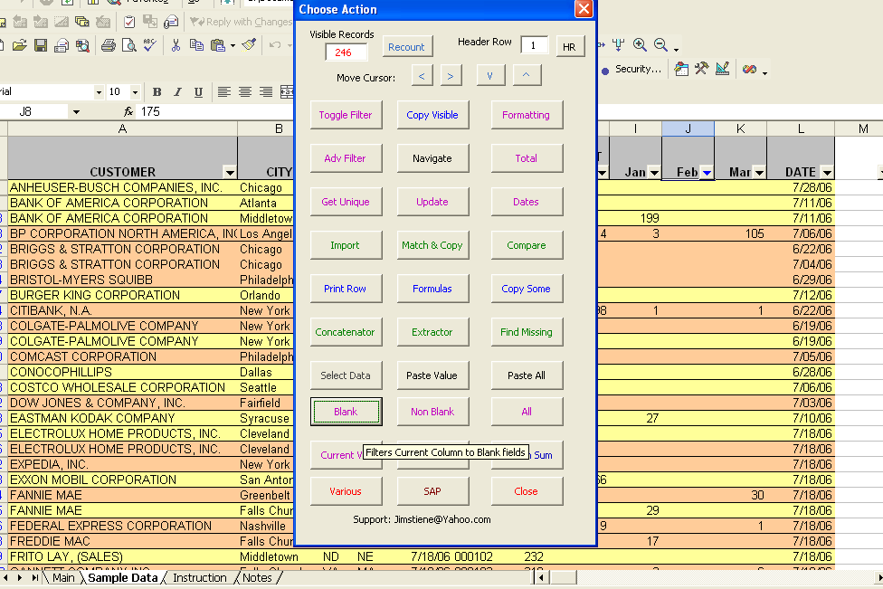

With your cursor still in column J or K, hit the Column Sum button. A message box pops up to tell you the Sum, Average, Max and count of visible rows. If you filtered the worksheet differently the Column Sum button would show different results.

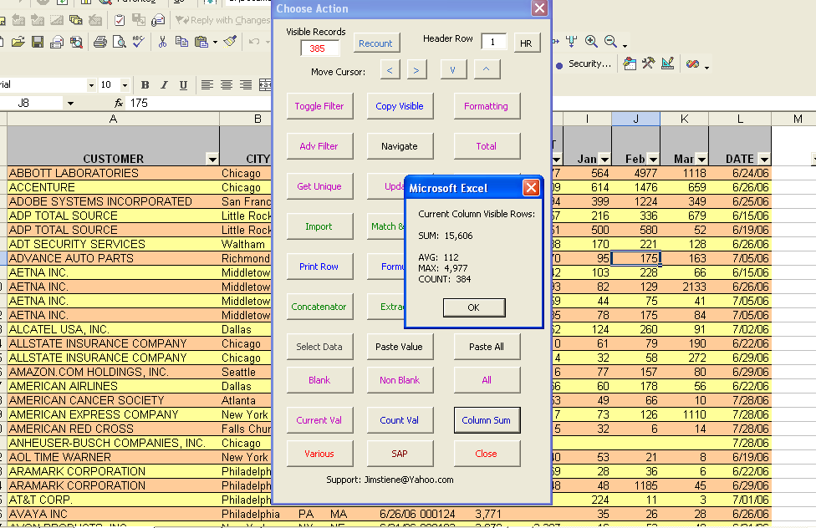

Put your cursor in a cell in column A that says AETNA and hit the Count Val button. Another message box pops up telling you how many times it appears in that row. This counts the number of times it exists in the row, regardless of any filters that are on. With your cursor still in a cell that says AETNA, hit the Current Val button.
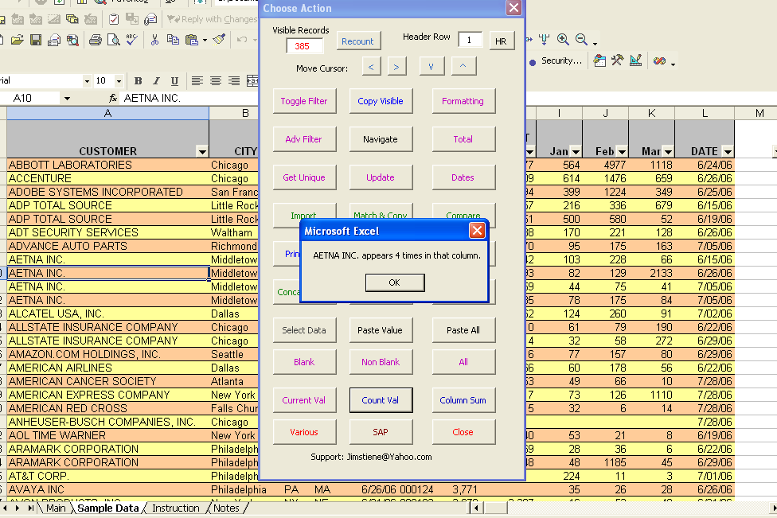
The Current Val button will filter the column to whatever value your cursor is in at the time. Notice how the Visible Records have changed. A lot of the buttons on the Main form will recount rows, but just manually filtering data in a sheet won’t trigger it to recount. Hit the All button again to turn filters to all in column A.

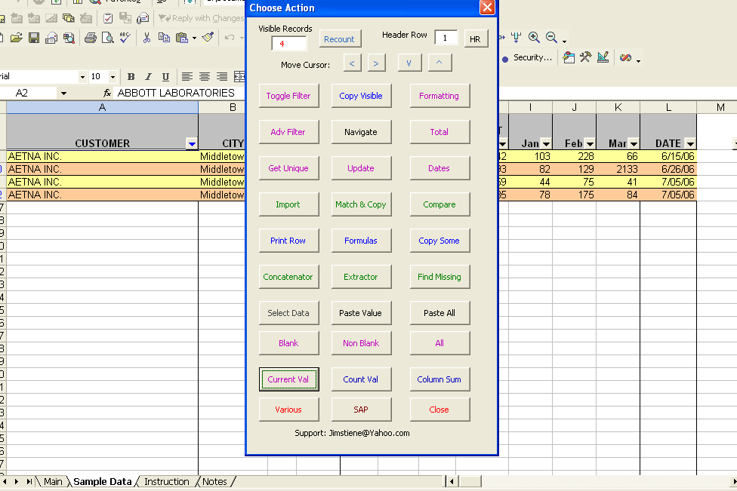

With all records showing again put your cursor in one of the rows with ALLSTATE and hit the Print Row button.

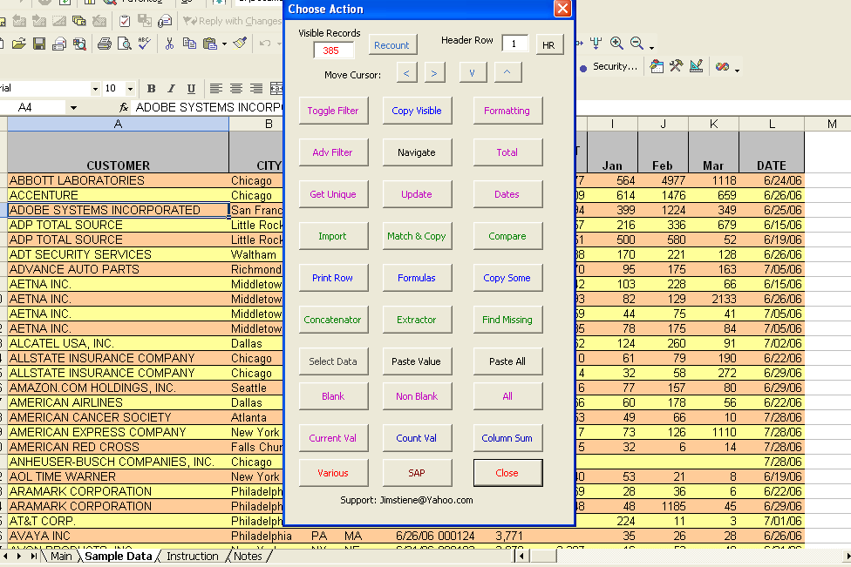

A new workbook is created with just the row ALLSTATE was in. It’s not very useful in a workbook with a few columns, but when there are a lot of columns it makes it easier to look at one row or record. The button will send data 7 rows across then keep moving down as many rows necessary to get all columns in one worksheet. It may or may not be printable at first so you might have to narrow a column or two slightly to make it printable in one sheet. Close the new workbook and go back to Excel Plus.

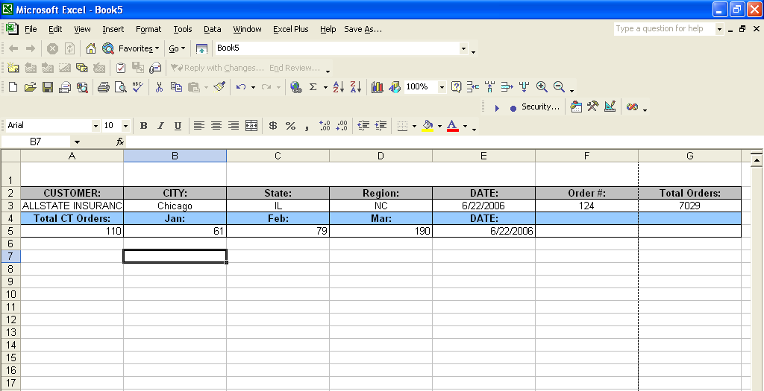
Back on the Sample Data hit the Get Unique button.

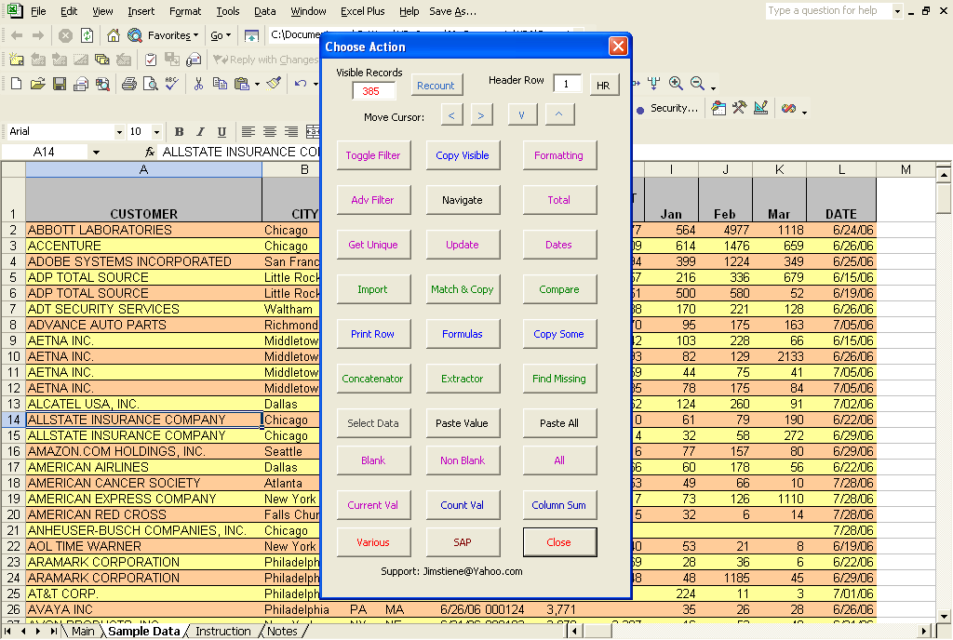
A new form will pop up. This is for making lists of all the values in a column and counting how often they appear. Put your cursor cell A1 to get a list of customers. It doesn’t need a header row listed because you should putt your cursor in the header row of the column you want to make a list of. The checkboxes on the bottom determine if the list is made in a new workbook or the current workbook. The Ignore Hidden button will not send values of hidden rows to the list. But for now, jut put your cursor in A1 and hit the Make List button.

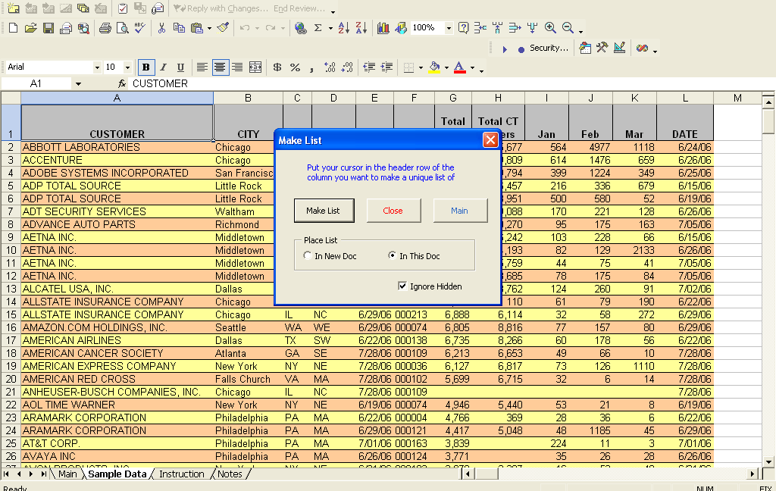
A new sheet is created called Customer, with a list of all customers and how often they appeared in the Sample Data tab. Hit CTRL-E or Excel Plus on the top menu to open up the Main form again.

\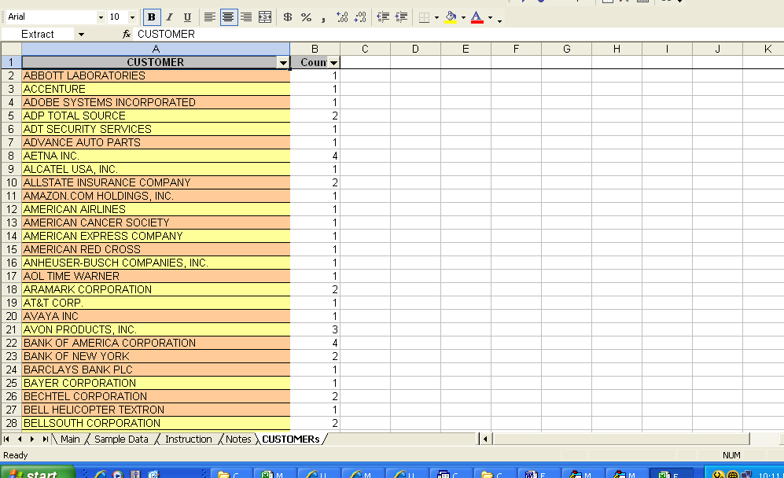

This time hit the Import button to bring up a new form.

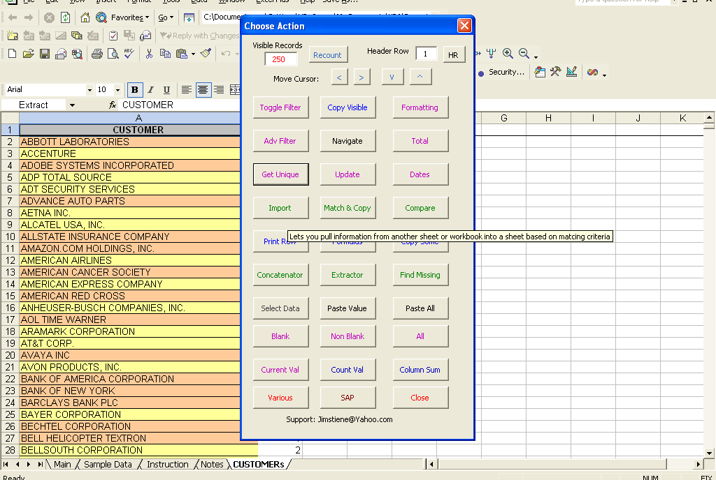
The Import button is kind of like a Vlookup function. You match fields from two different sheets, then import certain fields from the source sheet to the destination sheet. Choose Sample Data as the source sheet, CUSTOMER as the matching field in that sheet, then choose CUSTOMERs as the destination sheet, and CUSTOMER as the matching field in that sheet. Then choose City State and Region from the listbox below as the fields to import. For now ignore the other buttons and hit the Run button.

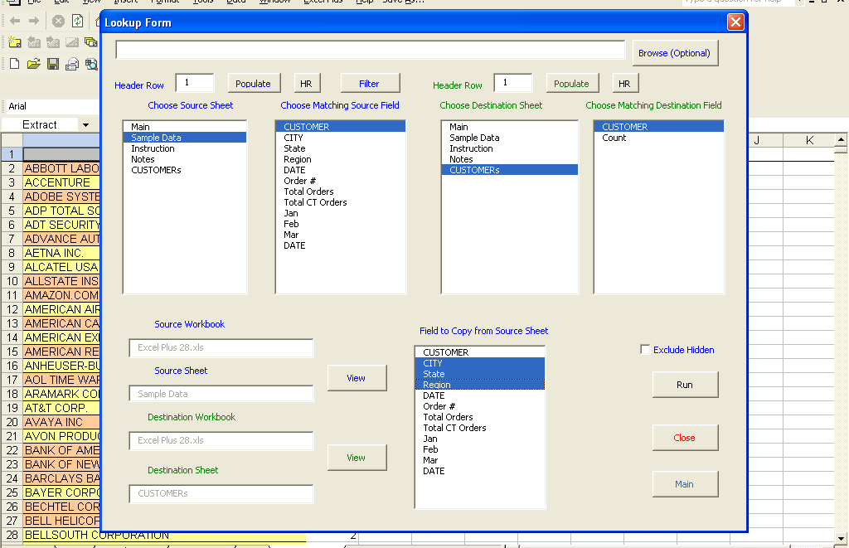
City, State and Region was imported from the Sample Data sheet, to the CUSTOMERs sheet by matching on the Customers field of both sheets.
Go back to the Sample Data sheet and open the Main form again.

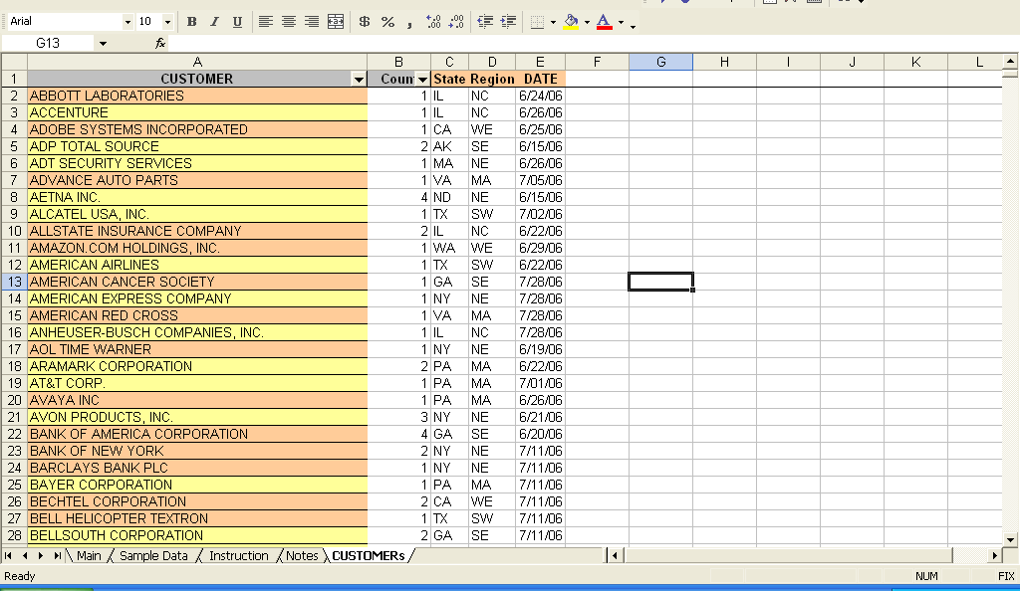
With the Main form open, hit the Get Unique button again.

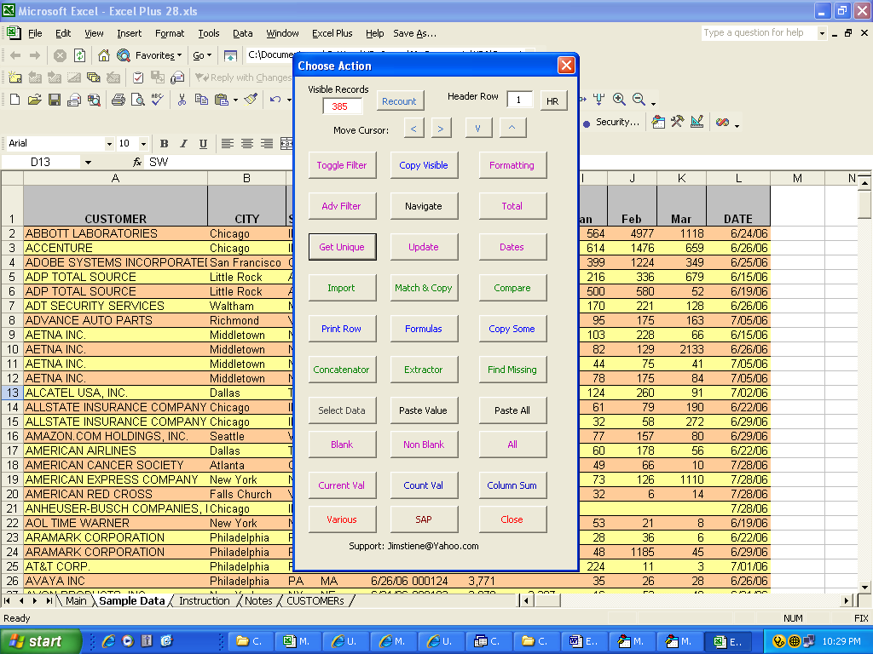

This time put your cursor in B1 and hit the Make List button, to get a list of Cities.

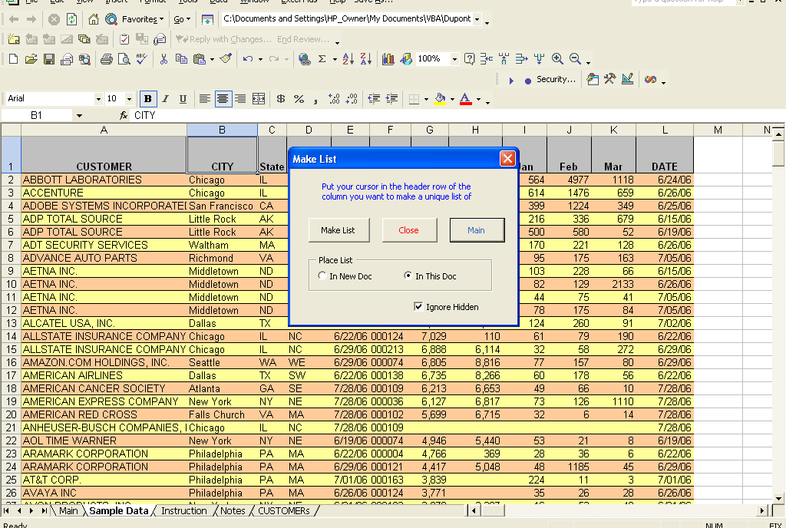
A new tab is created giving a list of Cities and the number of times they appear. Hit CTRL-E or Excel Plus from the Menu to bring up the Main form again.

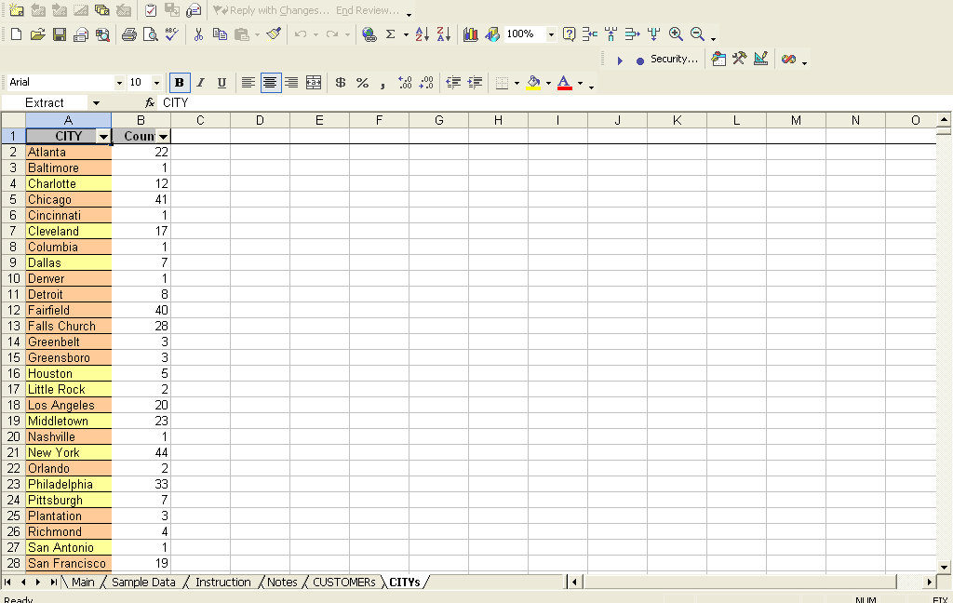
The Browse button is for importing information from another workbook altogether. In this case all the header rows are in 1, but if they weren’t you would have to set the header row of the source and destination sheets. The two View buttons on the bottom left are for viewing the source and destination sheets. The Exclude Hidden button is when you don’t want to import hidden rows from the source sheet. Choose Sample Data, CITY, CITYs, CITY, and State and Region, then hit Run button.
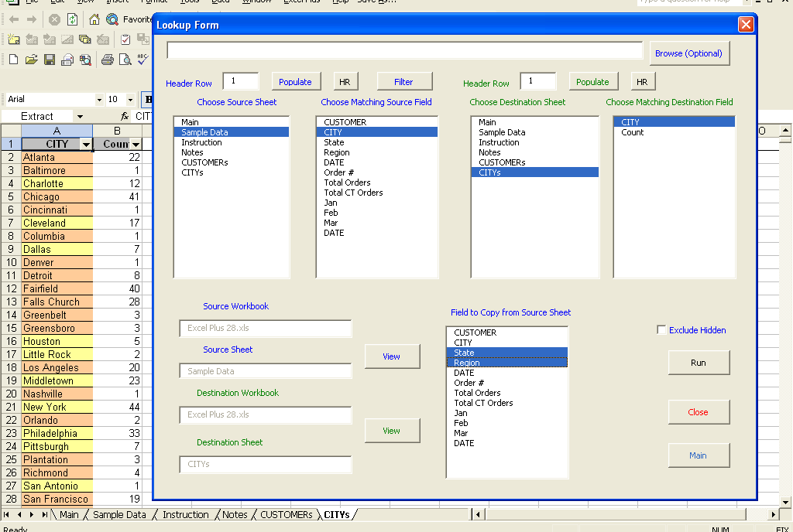
State and Region are imported from the Sample Data sheet to the CITIES sheet. Hit CTRL- E or Excel Plus to bring up the Main form again.

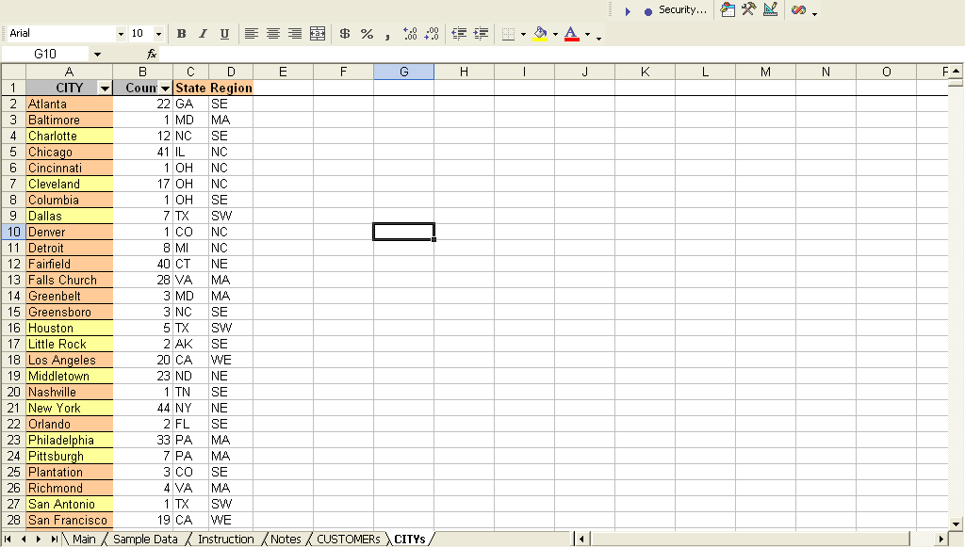

This time hit the Formatting button.

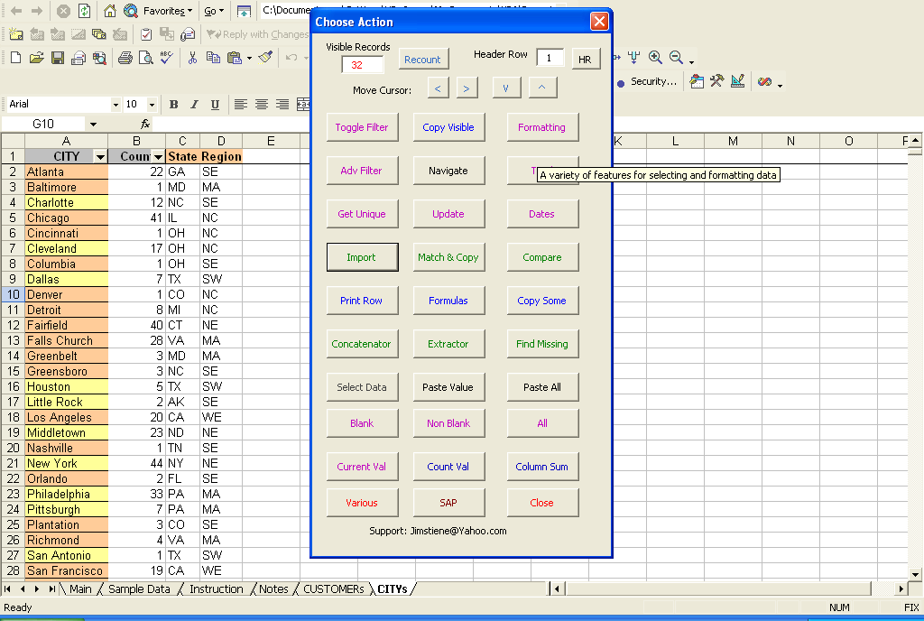

This form has a lot of options. Many are self explanatory, like Hide Row, Hide Column, Unhide Row, Insert Row, Freeze Panes, Unfreeze Panes, and towards the bottom, Default Row Height, Default Column Height. The colored buttons color the background of whatever sells are selected at the time. Put your cursor in cell A1 and hit Line and Color Value Change from the listbox.

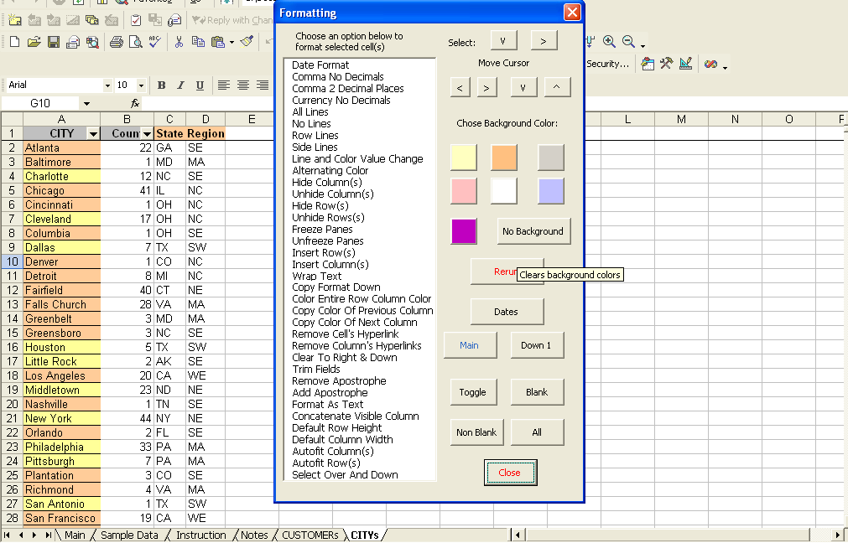
That removes all lines, the adds them every time a value changes in the column you are in, and alternates colors between yellow and orange.

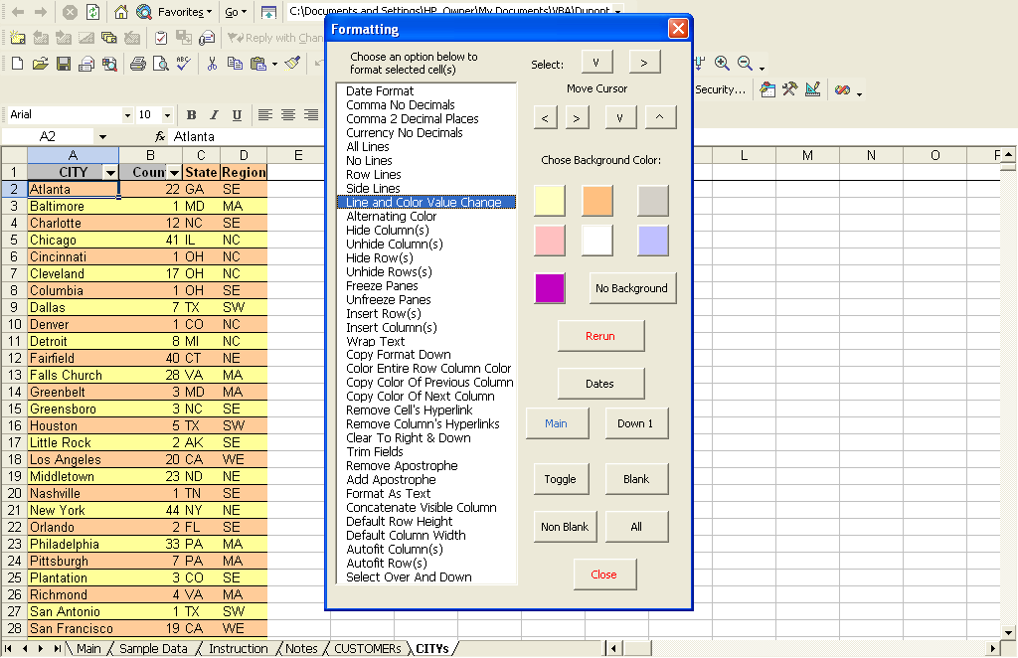
With the form open, go back to the Sample Data page. Put your cursor A1 and hit the Rerun button

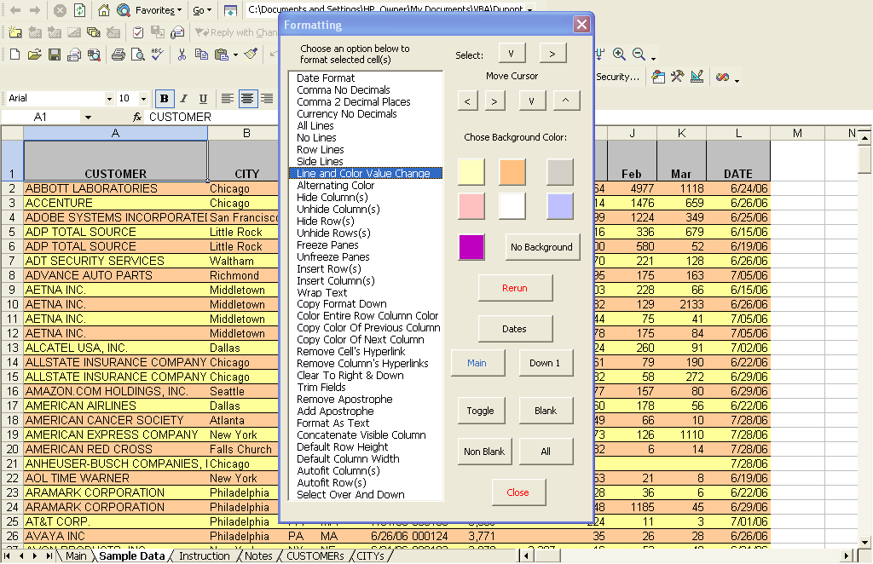

Notice how the colors and lines change when the value of column A changes. Put your cursor in B1 and hit the Rerun button.

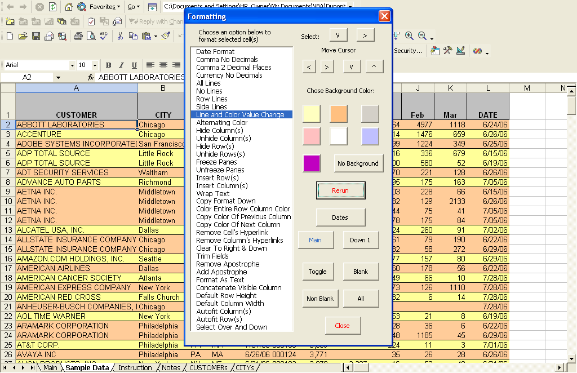
This time the lines and colors only change when values in column B change. You can do the same for the region column or any other. This button helps you to see information in different ways. Put your cursor in row 1 of any column and hit Alternating Color.

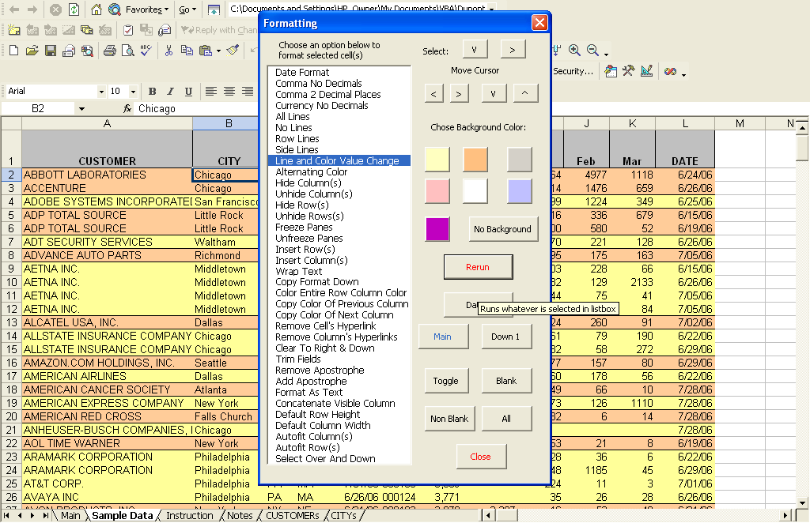

This just makes every other row a different color. If you hit Row Lines while your cursor is in the header row, it will give every row a line. Put your cursor in K1 and hit Comma No Decimals, Comma 2 Decimals, than Currency No Decimals to see how it formats number columns.

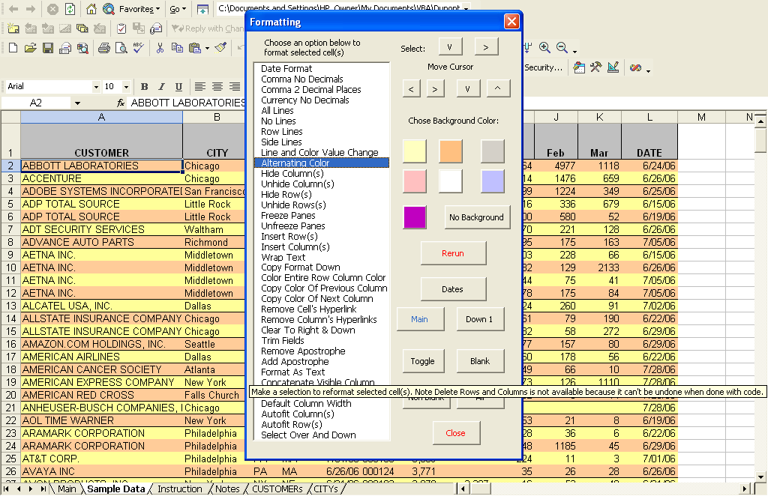
Color cell A2 white and select cells A2 and A3. Now chose the Copy Format Down from the listbox. Put your cursor in A1 and choose Color Entire Row Column Color to repeat the pattern across the data range. Now choose Row Lines from the Listbox. Copy Color of Previous and Next Column copy the colors in the columns to the left and right of the cursor, respectively. Put your cursor in A1 and hit Alternation Colors.
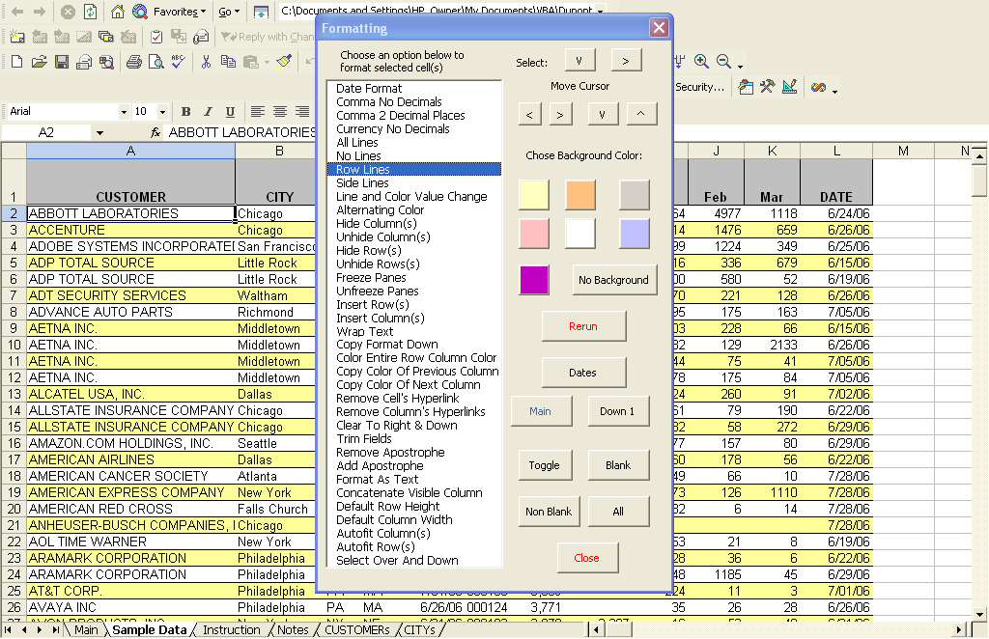

We’ll come back to the Formatting form, but for now, go back to the Main form and hit the Total button.

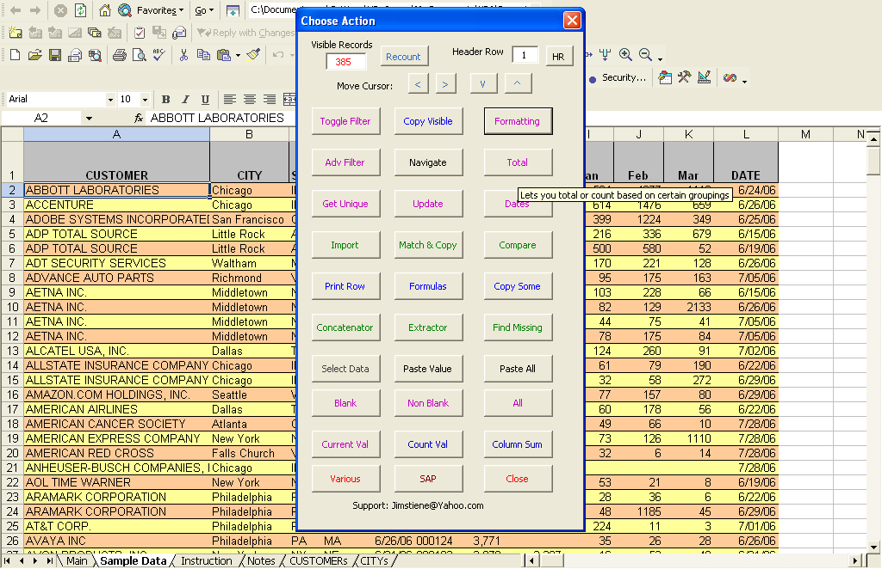
This lets you Total various fields by various criteria. Select City State and Region from the left listbox, and Jan Feb Mar from the right listbox.
Notice the header row buttons again. It is important to make sure they are set. You might also notice the In New Doc, and In This Doc option buttons, like the other form. The Select Type (Selection Type) button alters how you select fields in the right listbox. By holding down Ctrl or clicking on selections, separately, etc. You can experiment with it later, but for now, hit the Total button.

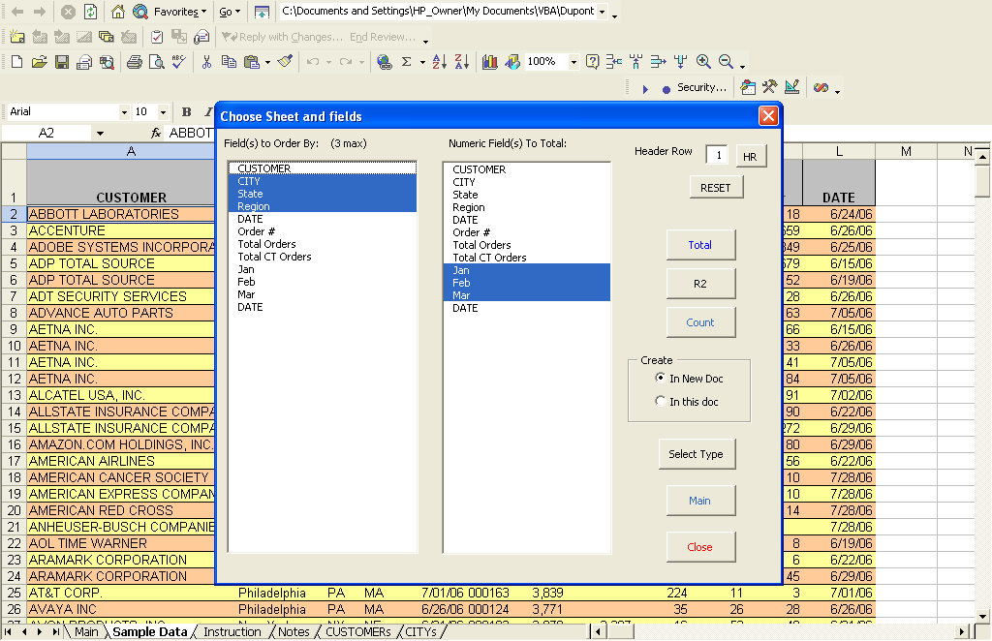
A new sheet is created showing totals and the count by the criteria you chose. If you had filters on, it would say, Limited to Chicago, or whatever else you had filtered, like the Copy Visible button. It also shows runtime information, and freezes panes on the first row of the first numeric column.

